**PSoC 5LP Magnetic Card Reader Project**

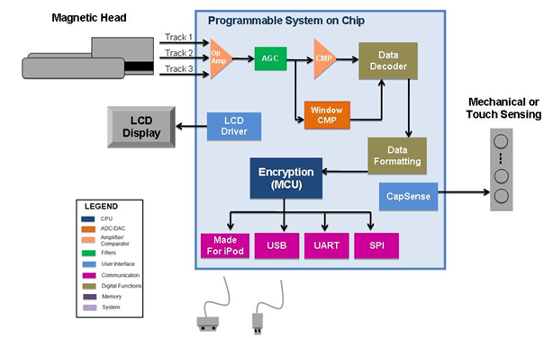

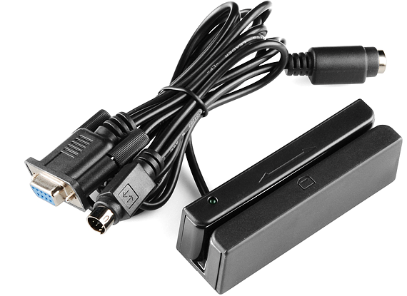 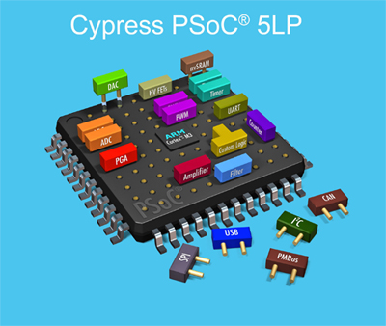

By Troy Pandhumsoporn

July 28, 2015

Independent Non-Academic Study Project/Design Challenge

**Main Objective:**

Slide a magnetic card through the reader in which data is transmitted serially through the RS-232 (UART) port on the PSoC 5LP development kit to the computer. Open up a terminal/client such as Putty, HyperTerminal, or TeraTerm program, etc. and view pure ACSII/serial data streams on the computer.

**Other objectives:**

Understand the layout on how the serial information is laid out. Find/develop de-encryption software that could decode or make sense of magnetic card data to view what information is actually imprinted on a magnetic card. If the data is already decoded, then sift through the data finding relevant patterns or borders that indentify categories of groupings.

Attempt to

Magnetic Card Reader C library

<http://www.instructables.com/id/Turn-your-Arduino-into-a-Magnetic-Card-Reader/step9/Code-Download-and-Wrapup/>

<http://www.instructables.com/id/Arduino-magnetic-stripe-decoder/>

<http://stripesnoop.sourceforge.net/>

http://www.element14.com/community/docs/DOC-48037/l/cypress-an54374--application-note-on-magnetic-card-reader-for-psoc-3-family

http://www.instructables.com/files/orig/F8F/O3U9/FJBYZ4T9/F8FO3U9FJBYZ4T9.txt

http://www.element14.com/community/docs/DOC-62279/l/cypress-an54374--software-code-for-magnetic-card-reader-using-psoc-creator-beta5

The PSoC 5LP Implementation of a Three Track Magnetic Card Reader with Automatic Control Gain Feature  
http://ftp1.digi.com/support/documentation/0220082_b.pdf

The Magnetic Card Reader is now a ubiquitous form of information exchange in thousands of everyday applications that range from retail credit card terminals to ATMs to access control systems, a magnetic stripe card is a type of PVC card with a band of magnetic material embedded into resin on the back of the card. The flexibility and power of the PSoC architecture allow embedded designers to include a two-channel Magnetic Card Reader into their applications for virtually no cost, while the new reference design provides this subsystem in a complete and tested form to simplify the development process.

As we know that the smart Magnetic Card Reader has a guide and a connector that engages contacts on the card. When the machine senses that the card is in place and the related code has been keyed in, the memory device embedded in the card can be read. Some types can also modify the data on the card, e.g. debiting the amount of credit available. There is no doubt that it is so useful and necessary for our life.

The usual reason that some people won't buy that kind of technology is that it is bulky, expensive and they don't have a permanent place of business where they can install that in. Magnetic Card Reader on magneticcardreaderwriters are commonly used, you can see it at so many place. After more than 40 years of relying on the same basic [Credit Card Reader](http://www.magneticcardreaderwriters.com/Credit-Card-Reader1.html) technology, the humble plastic credit card is about to get smart. From cards with buttons and displays on the front to those that can be programmed to keep you on a budget, a number of new innovations are in the works. Europe moved to smarter, chip-enabled cards years ago, but the size of the magnetic stripe infrastructure in the U.S. has made that type of widespread change difficult, since millions of new card readers would be required. So in a new twist, some companies are now creating interactive cards that work with ordinary Magnetic Card Reader and the [Magnetic Card Reader Writer](http://www.magneticcardreaderwriters.com/).

Electronics engineers can now leverage the flexible Magnetic Card Reader architecture and pre-developed magnetic card sub-system to cut development time and reduce the bill-of-materials cost with the integration of the analog front end and associated A/Ds while leaving plenty of processing power and other PSoC resources for further system integration.

A magnetic stripe card reader for reading a magnetic stripe on a card having at least one track of magnetically stored information stored thereon as a stream of encoded discrete data bits separated by bit times is disclosed. Aa magnetic head is provided for reading the magnetic pulses as the magnetic stripe is passed thereby to output a time varying analog signal. A data converter incorporated on an integrated circuit is then operable for converting the analog signal to a digital time series of digital values. A processor incorporated on the integrated circuit can ten process the digital output of the data converter and is operable to first determine potential bit boundaries and then recover timing information from the digital time series to discriminate the bit times between data bits. The value of each data bit is then determined during each bit time to provide a stream of extracted data bits.

**Abstract**

Using the

DB9 Pinout

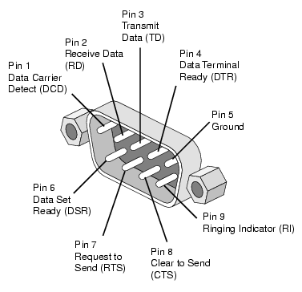

**Figure _:** DB9 Connector (RS-232) Serial Port on the PSoC 5LP board and the magnetic card reader requires an M/M adapter or respective wires, and physically represents the UART interface for the system.

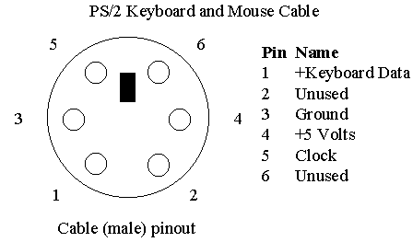

**Figure _:** To power the magnetic card reader, Pin 3 and Pin 4 are the only pins needed to connect respectively to GND and Vdd

The PSoC 5LP has a wide array of power options: The 12V DC-DC power adapter could be used to power the development using a wall socket with a medium sized cord. A 9 V battery can be used for portable alkaline battery application on the go.

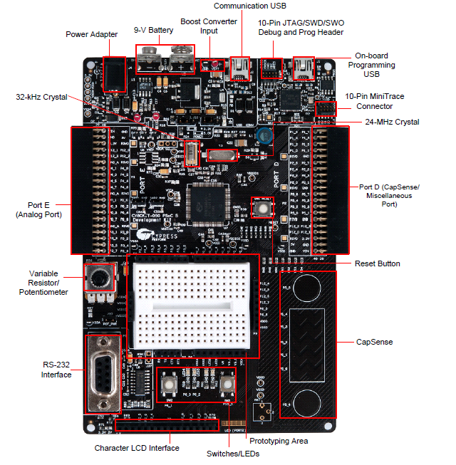

**Figure _: PSoC 5LP development Kit Layout**

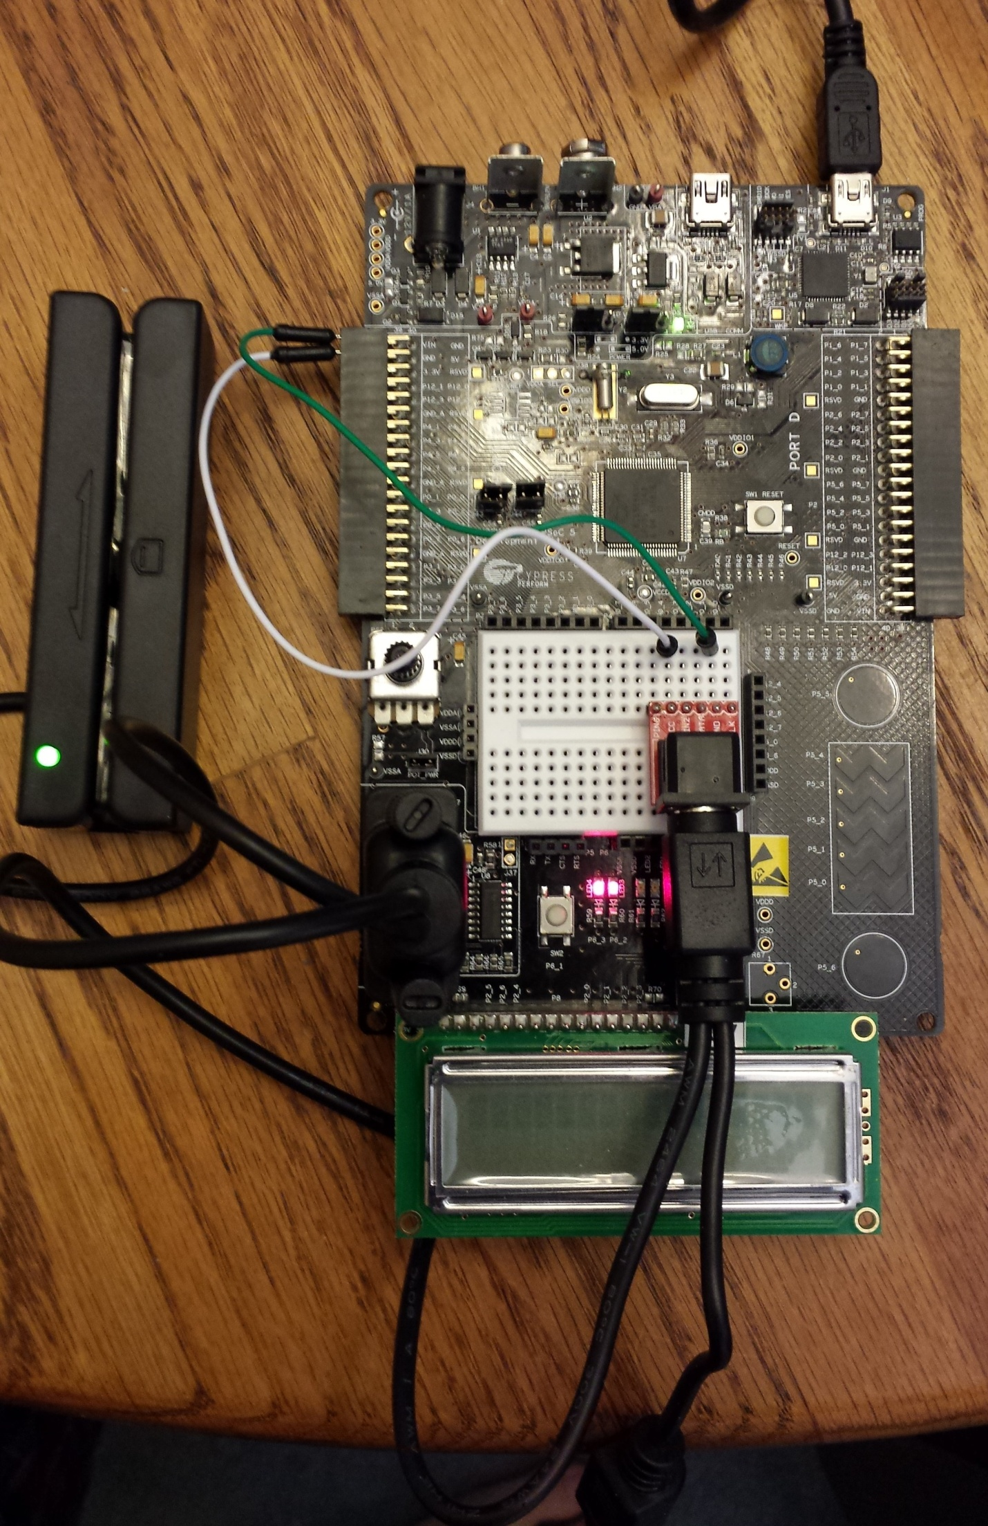

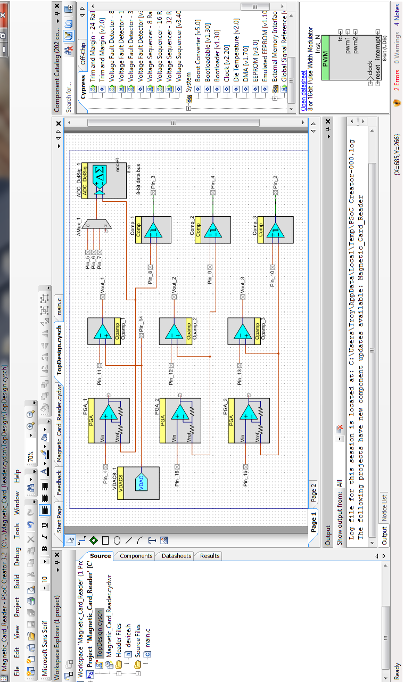

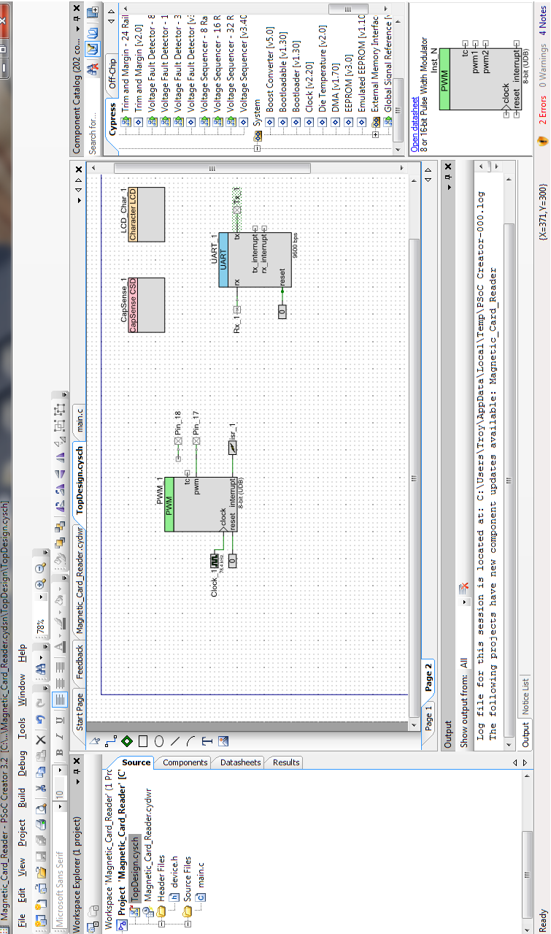

**Improvements**:

* Interested coworkers/partners/collaborators with a better understanding of embedded systems programming (oriented with how security systems work) and computer systems/software engineering could help realize it as a product.
* The character LCD interface could use a larger LCD instead of the stock 3.3V 16x2 LCD provided in the kit (at least the 20x4 to provide more serial information on the display or even a graphical LCD module could work). The SMT resistor will have to be re-soldered onto the 5V if possibly for those models. Because of the author’s inability to solder small SMT parts (burned through a whole stock of one type of SMT), the task is left to someone else more skilled to take this project from evaluation to production.
* CY3280-MBR3 Cap Sense® MBR3 Evaluation Kit: The Cap Sense provided in the PSoC 5LP can be expanded upon by buying this evaluation kit; however, an off-the-shelf capacitive/mechanical keypad can be added for better user interface as opposed to a card swipe and a few buttons/sliders from the kit itself.

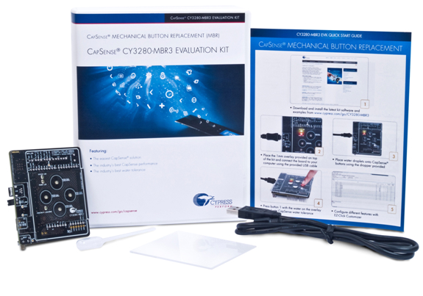

**Bibliography**

**Theory behind the Magnetic Card Reader**

**http://www.google.cl/patents/US7163148**

**http://www.google.com/url?sa=t&rct=j&q=&esrc=s&source=web&cd=21&ved=0CDwQFjAAOBQ&url=http%3A%2F%2Fwww.cec-mc.ru%2Fdata%2Ffiles%2FFile%2FPDF%2FPSOC.ppt&ei=8vPBUpHsHMnxoATbwoGIBQ&usg=AFQjCNF14jEZ5JwIxKQ5dJvPW4tXHYXu4A**

[www.cec-mc.ru/data/files/File/PDF/**PSOC**.ppt](http://www.cec-mc.ru/data/files/File/PDF/PSOC.ppt)

[**http://electronics.stackexchange.com/questions/2725/pinout-of-a-3-wire-magnetic-card-reader**](http://electronics.stackexchange.com/questions/2725/pinout-of-a-3-wire-magnetic-card-reader)

<http://www.eettaiwan.com/ARTICLES/2001OCT/PDF/2001OCT04_AMD_CT_AN2112.PDF>

**Arduino Sample Code**

**http://www.element14.com/community/docs/DOC-48037/l/cypress-an54374--application-note-on-magnetic-card-reader-for-psoc-3-family**

[**http://code.google.com/p/magstripelib/**](http://code.google.com/p/magstripelib/)

**http://www.dtweed.com/circuitcellar/caj00216.htm**

**http://www.blogymate.com/post.aspx?blogid=4323092&t=Magnetic-Card-Reader-is-now-a-ubiquitous-form-of-information-exchange**

**http://www.cypress.com/?rID=46526&source=header**

[**http://www.cypress.com/?rID=45518**](http://www.cypress.com/?rID=45518)

**http://www.repairfaq.org/filipg/LINK/F_Phrack_Mag.html**

**Google: magnetic stripe card reader source code**